* SAMPLE- This assessment consists of 13 sections:
  + 1st section contains 2 Multiple Choice Questions on Algorithms & Data Structures similar to questions in All Software Engineer assessments.
  + 2nd section contains 2 Multiple Choice Questions on Fundamental Front-end Concepts similar to questions in Frontend assessment.
  + 3rd section contains 3 Multiple Choice Questions on Fundamental API/REST Concepts similar to questions in Backend, Fullstack and Infrastructure assessments.
  + 4th section contains 2 Multiple Choice Questions on DevOps similar to questions in All Engineer assessments.
  + 5th section contains 3 Multiple Choice Questions on IT Service Management similar to questions in All Engineer assessments.
  + 6th section contains 7 Multiple Choice Questions on Infrastructure Engineering related to SAP Basis, Mainframe, Desktop, Collaboration Services, Networking, and Cloud similar to questions in Infrastructure assessment.
  + 7th section contains 3 Multiple Choice Questions on Systems Design Principles similar to questions in Infrastructure assessment.
  + 8th section contains 3 easy difficulty SQL challenges similar to questions in Backend & Data assessments.
  + 9th section contains 3 medium difficulty SQL challenges similar to questions in Backend, Fullstack, and Infrastructure assessments.
  + 10th section contains 1 hard difficulty SQL challenge similar to questions in Data assessment.
  + 11th section contains 2 easy difficulty Coding challenges similar to questions in All Engineer assessments.
  + 12th section contains 2 medium difficulty Coding challenges similar to questions in Backend, Fullstack and Data assessments.
  + Final section contains 1 easy difficulty Javascript challenge similar to questions in Frontend assessment.

Original

* Section 1 have 1 Multiple Choice Question on Fundamental Development Concepts for 5 total points.
* Section 2 has 2 Multiple Choice Questions on Intermediate REST API, Data Structures & Algorithms for 10 total points.
* Section 3 have 1 Multiple Choice Questions on DevOps for 5 total points.
* Section 4 has 1 Multiple Choice Questions on NoSQL Databases for 5 total points.
* Section 5 has 1 easy difficulty Coding Question for 50 total points.
* Section 6 has 1 medium difficulty Database Engineer Question for 75 total points.

**105 minutes**

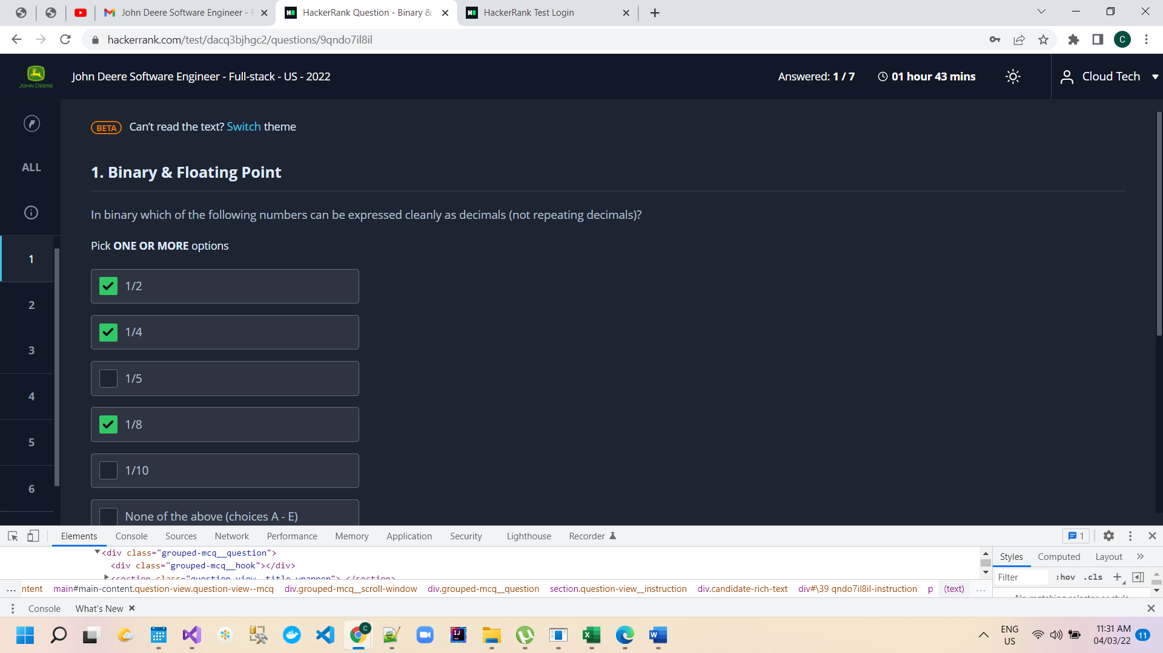

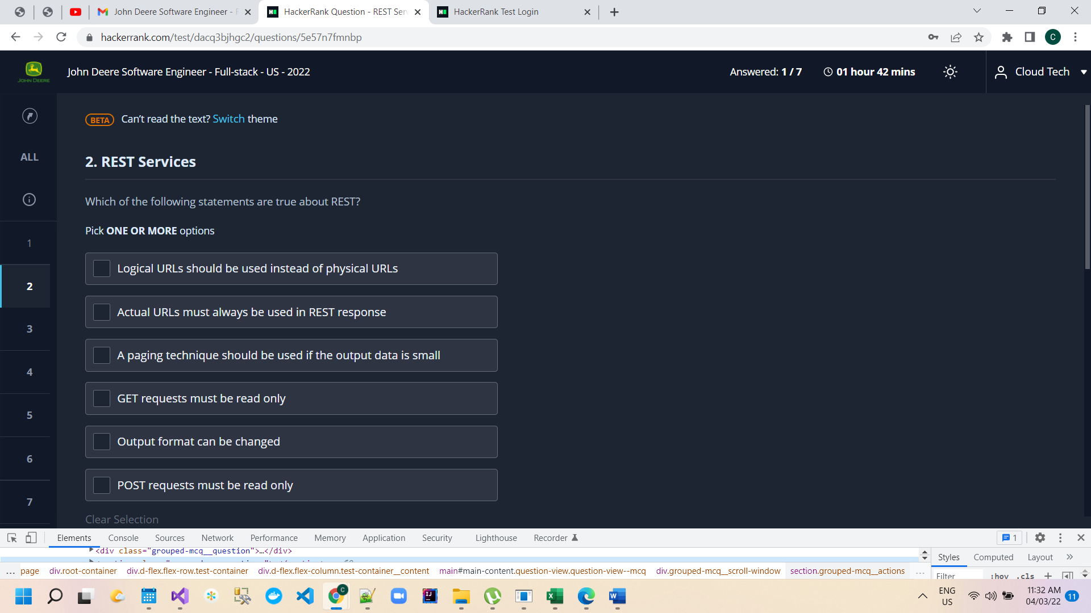

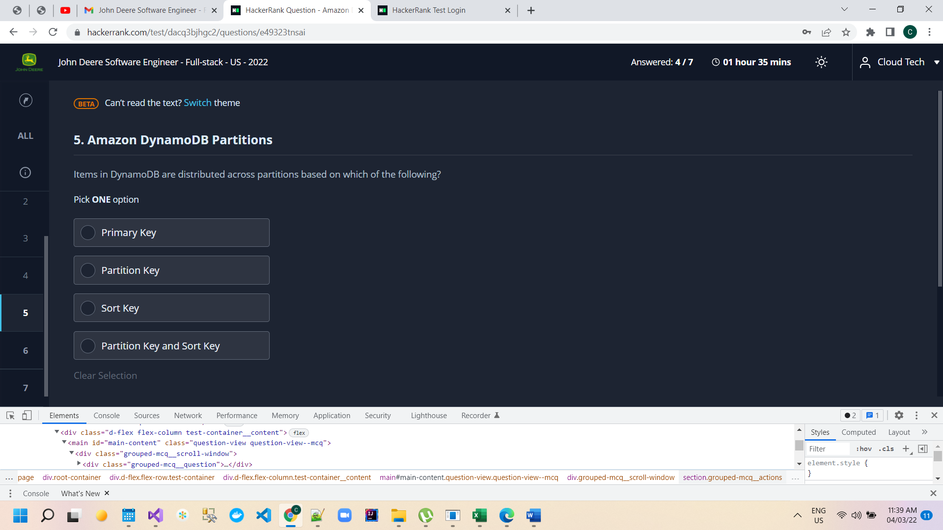

A unique character is one that appears only once in a string. Given a string consisting of lowercase English letters only, return the index of the first occurrence of a unique character in the string using 1-based indexing. If the string does not contain any unique character, return -1.

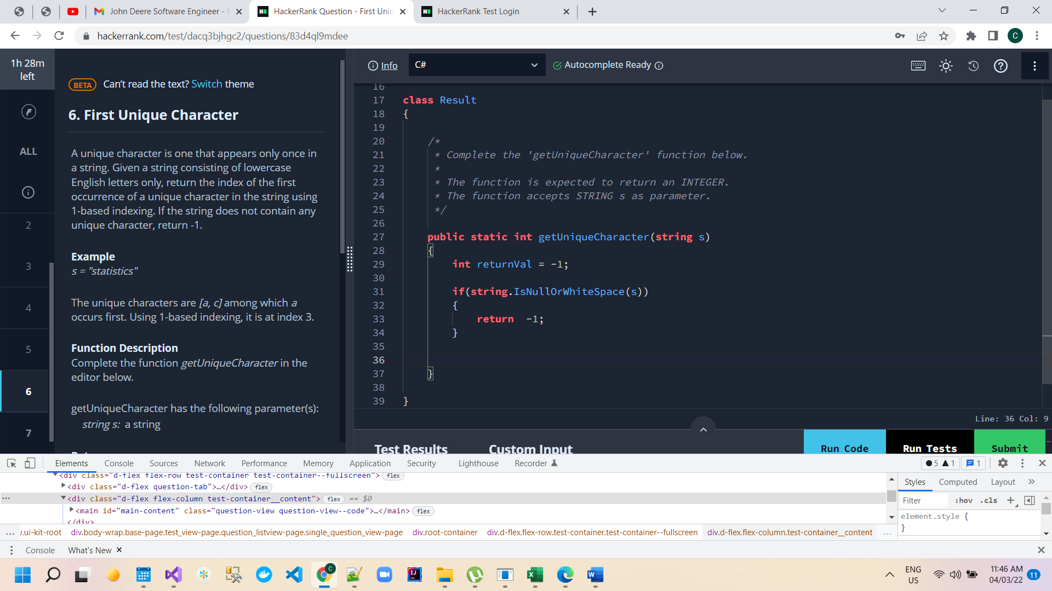

// Method 1 - all test case passed

int[] a = new int[26];

for (int i = 0; i < 26; i++)

a[i] = 0;

for (int i = 0; i < s.Length; i++)

{

int m = s[i];

a[m - 97]++;

}

for (int i = 0; i < s.Length; i++)

{

int t = s[i];

if (a[t - 97] == 1)

{

return i + 1;

}

}

return -1;

// Method 2 only 9 test case passed out of 15

for (int i = 0; i < s.Length; i++)

{

bool isDuplicateCharacterExist = false;

for (int j = i + 1; j < s.Length; j++)

{

if (s[i] == s[j])

{

isDuplicateCharacterExist = true;

break;

}

}

if (!isDuplicateCharacterExist)

{

return i + 1;

}

}

return -1;

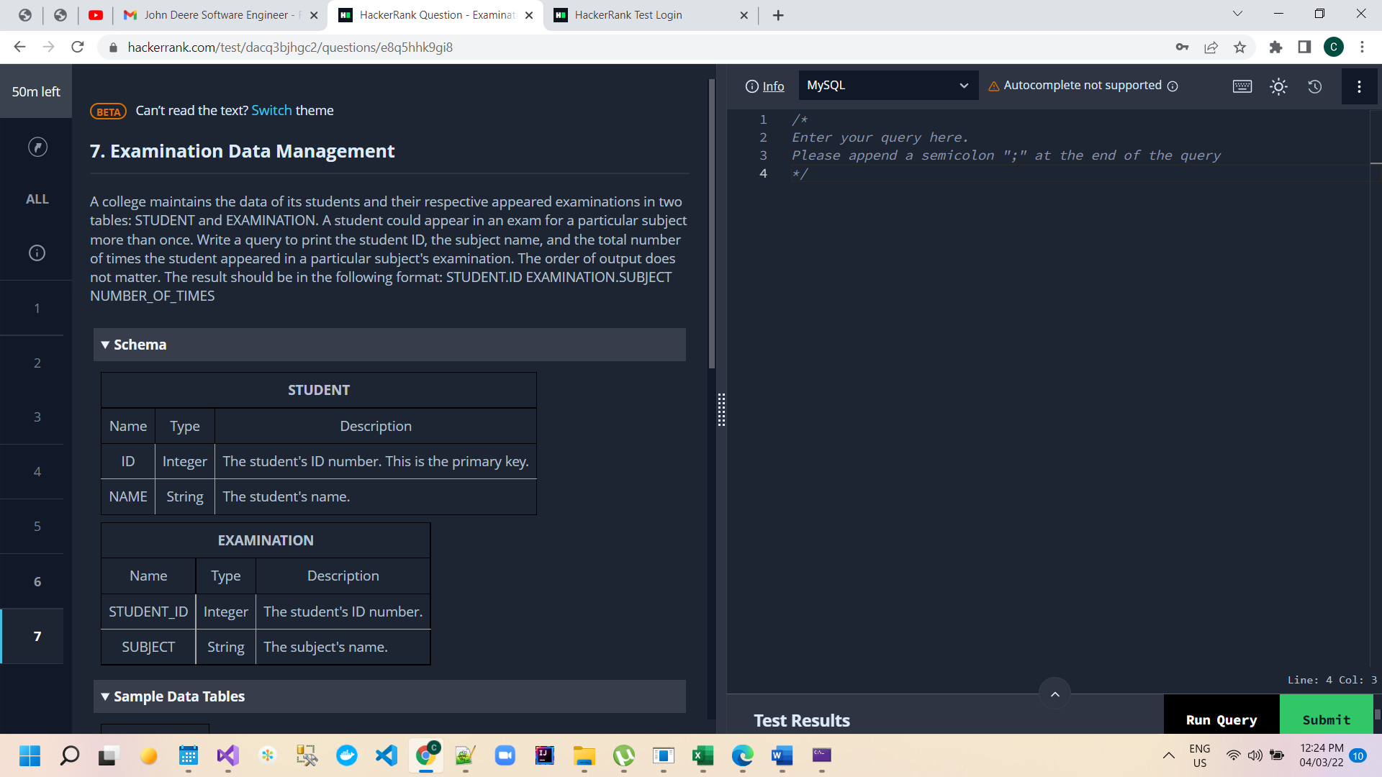

A college maintains the data of its students and their respective appeared examinations in two tables: STUDENT and EXAMINATION. A student could appear in an exam for a particular subject more than once. Write a query to print the student ID, the subject name, and the total number of times the student appeared in a particular subject's examination. The order of output does not matter. The result should be in the following format: STUDENT.ID EXAMINATION.SUBJECT NUMBER_OF_TIMES

**SELECT** e.student_id, e.**subject**, COUNT(*) **AS** no_of_times

**FROM** Examination e join student  s

**on** e.student_id= s.ID

**GROUP** **BY** e.student_id, e.**subject**;

**SELECT** s.ID, e.**subject**, COUNT(*) **AS** no_of_times

**FROM** Examination e join student  s

**on** e.student_id= s.ID

**GROUP** **BY** s.ID, e.**subject**;

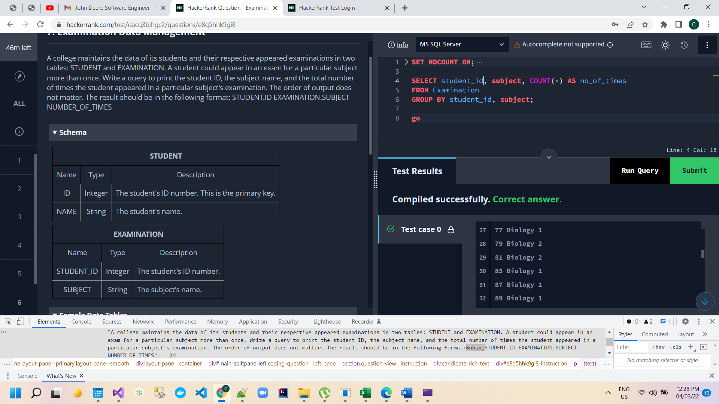

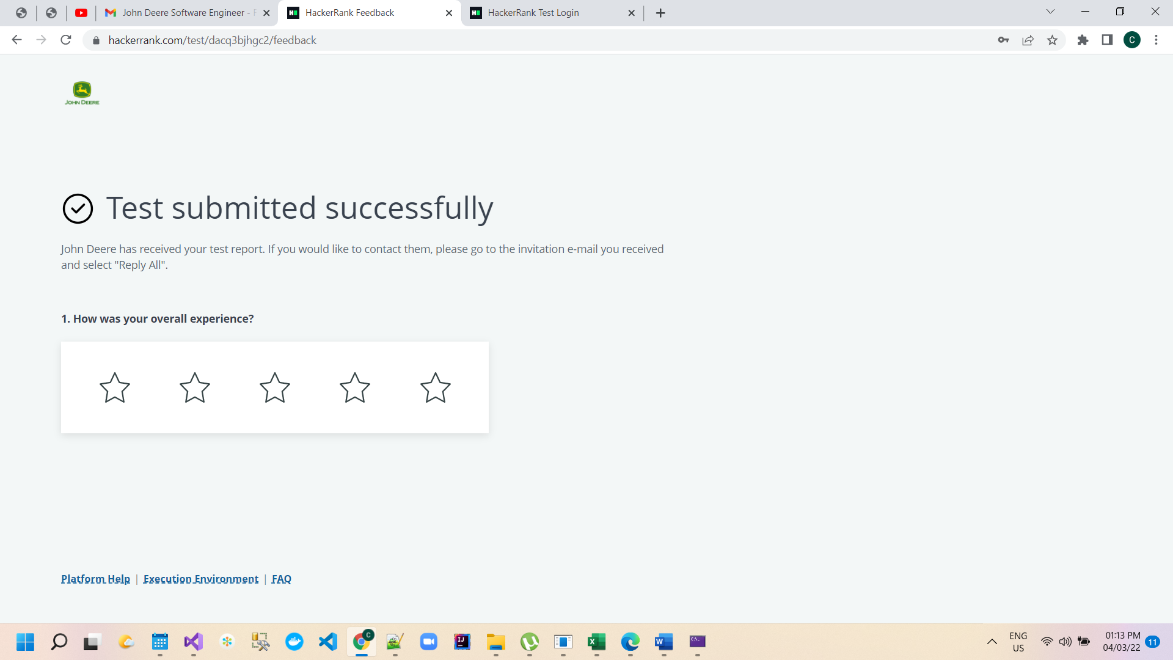

**Sample Below**

